**S.3 PHYSICS SELF ASSESSMENT EXERCISE ON PRESSURE**

**Time allowed: 2Hours**

**Instructions:**

* ***For numbers 1 through 25, circle the correct alternative***
* ***For numbers 26 through 26, write your answers on answer sheets.***

1. A tank is filled with water to a depth of 3 m. What is the pressure at the bottom of the tank due to the water alone? (dwater = 1000kg/m3)

A. 30 kPa B. 15 kPa C. 3 000 Pa D. 1 500 Pa

2. A diver is searching for treasure at a depth of 40m below the surface. What is the pressure exerted on the diver. (Patm = 100 000 N/m2; dwater = 100 kg/m3)

A. 400 000 N/m2 B. 200 000 N/m2 C. 500 000 N/m2 D. 50 000 N/m2

3. What is the pressure at the bottom of a 3 km deep oil well filled with oil of density 860kg/m2?

A. 5 400 kPa B. 1 080 kPa C. 10 800 kPa D. 25 800 kPa

4. What is the total pressure on a fish swimming in the sea at a depth of 2 m below the surface? (dsea = 1 125 kg/m3, Patm = 101 300 Pa)

A. 22.5 kPa B. 123.8 kPa C. 32.6 kPa D. 132.5kPa

5. The piston of a hydraulic automobile lift has 0.48 m2 area. What pressure is required to lift a car of mass 1 200 kg?

A. 25 kPa B. 12 kPa C. 30 kPa D. 60 kPa

6. In the hydraulic lift, the area of the smaller piston is one fourth that of the larger piston. If 40 N force is applied on the smaller piston, what is the force on the bigger piston?

A. 640 N B. 160 N C. 10 N D. 320 N

7. In a hydraulic press a force of 40 N is applied to a piston of area 0.1m2. The area of the other piston is 4m2. What is the pressure transmitted through the liquid and the force on the other piston?

A. 800 N/m2; 3 200 N B. 400 N/m2; 1 600 N C. 400 N/m2; 400 N D. 800 N/m2; 1 600 N

8. A hydraulic jack is made with a small piston 12 cm2 that is used to move a large piston 108 cm2. If a man can exert a force of 270 N on the small piston, how heavy a load can he lift with the jack?

A. 1 215 N B. 2 430 N C. 4 860 N D. 3 645 N

9. A hydraulic press has a large piston with a cross-sectional area of 250 cm2 and a small piston with a cross-sectional area of 1.25 cm2. What is the force on the large piston when a force of 1 250 N is applied to the small piston?

A. 375 000 N B. 125 000 N C. 500 000 N D. 250 000 N

10. In a liquid, pressure is

A. Transmitted in a specific direction B. Transmitted in all direction.

C. Decreased with depth D. Decreased with density

11. Pressure in a liquid is independent of the

A. density of the liquid

B. depth below the surface of the liquid

C. pressure exerted on the surface of the liquid above

D. cross-sectional area and the shape of the vessel containing the liquid

12. A rectangular block of metal weighs 3N and measures (2 x 3 x 4) cm3. What is the greatest pressure it can exert on a horizontal surface.

A. 5.0 x 103 Nm-2 B. 3.75 x 103 Nm-2 C. 2.5 x 103 Nm-2 D. 7.5 x 10-1Nm-2

13. The mass of a cuboid of dimensions 4 m x 2 m x 3 m is 48 kg. The minimum pressure it can exert is

A. 20 Nm-2 B. 40 Nm-2 C. 60 Nm-2 D. 80 Nm-2

14. In a hydraulic machine

A. an object displaces its own weight of fluid

B. the pressure transmitted in the fluid is the same in all directions

C. the volume of fluid compressed is proportional to the applied force

D. an object experiences an upthrust equal to the weight of fluid displaced

15. Which one of the following is true about a manometer?

(i) It uses mercury because mercury is a good conductor of heat.

(ii) It is used for measuring gas pressures.

(iii) The maximum height of mercury it can support is 760mm.

A. (i) and (ii) only B. (i) and (iii) only C. (ii) only D. (ii) and (iii) only.

16. What is 730mm Hg in Nm2 ?

A. B.  C.  D. 

17. A metal cylinder contains a liquid of density 1100 kg/m3. The area of the base of the cylinder is 0.005 m2 and the height of liquid is 5m. Calculate the force exerted by the liquid on the base of the cylinder.

A. 27.5 N B. 55 N C. 220 N D. 275 N

**18.**  A uniform tube with a narrowed middle part has three identical manometers attached to it as in the figure 9.21 below. If a steady flow of a liquid is maintained in the direction indicated by the arrows, the height of the liquid will be

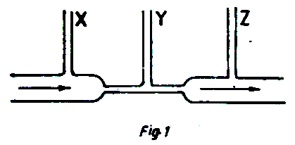

Figure 9.21

A. greatest in X and Y B. greatest in Y

C. greatest in Z D. equal in X, Y and Z

**19.** Which one of the following are true about a hydraulic brake?

(i) It uses water.

(ii) The brake pedal is connected to the master cylinder.

(iii) The return spring returns the brake drum in position.

(iv) The return spring returns the brake shoe in position.

A. (i) (ii) and (iii) B. (ii) (iii) and (iv) C. (ii) and (iv) D. (iii) and (iv) only.

**20.** Which one of the following statements is false? The pressure in a liquid

A. at any one point in a liquid would not change even when more liquid is added.

B. at any one point depends only on the depth and density.

C. at any one point acts equally in all directions.

D. increases with depth.

**21.** When the handle, H, of the force pump shown in figure 9.22 below is moved upwards, the valves at

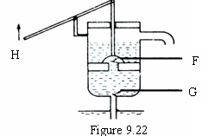

A. F and G will both close

B. F and G will both open

C. F will close, and G will open

D. F will open and G will close

**22.** A rectangular block of dimensions 4 cm x 2 cm x 1cm exerts a maximum pressure of 200 Nm-2 when resting on a table. Calculate the mass of the block

A. 4 g B. 16 g C. 40 g D. 400 g

**23.** Calculate the increase in pressure which a diver experience when he descends 30m in sea water of density 1.2 x 103

A. 3.0 x 102 Nm-2 B. 1.2 x 104 Nm-2 C. 3.6x104 Nm-2 D. 3.6 x 105 Nm-2

**24.** In a hydraulic press, the area of the piston on which the effort is applied is made smaller in order to

A. facilitate the movement of the piston downwards

B. transmit a force as large as possible to the load

C. transmit pressure equally through out the liquid

D. obtain a pressure as large as possible.

**25.** Which of the following is true about pressure in liquids? It

A. increases with the surface area of the liquid B. is directly proportional to the depth

C. depends on the shape of the container D. is the same at equal depths in all liquids

**SECTION B**

**26. (a) (i)** Define pressure and state its units.

**(ii)** With the aid of a diagram, describe how you would show that the pressure of a liquid is in dependent of cross-sectional area and shape of a container.

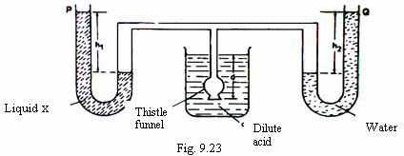**(b)** Two manometers P and Q contain a liquid X, and water respectively at the same level. They are then connected to a thistle funnel covered with a rubber membrane as shown in figure 9.23. When the thistle funnel is lowered into a beaker containing a dilute acid of density 1200 kgm-3, the heights h1 and h2 are 15 cm and 12 cm respectively.

Find the: (i) Ratio of the density of liquid X to that of water,

(ii) Depth d of the thistle funnel below the surface of the dilute acid.

Dilute acid

(iii) Explain why a ship floats in water although it is made mainly of metal.

**27. (a) (**i) State the principle of transmission of pressure in fluids.

(ii) Give one assumption on which the principle is based.

(iii) State two application of the principle.

(iv) In a hydraulic press the smaller piston has a diameter of 14 cm while the larger has a diameter of 280 cm. If a force of 77 N is exerted on the smaller piston, calculate the force exerted the larger piston.

**(b)** With a help of diagram, describe how hydraulic brake works.

**28. (a)** Explain why large water reservoirs are much wider at the base than at the top.

**(b)** Figure 9.24 shows the structure of a force pump.

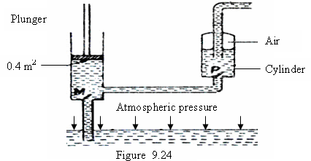

**(i)** Describe the action of the pump.

**(ii)** If a downward of 500 N is exerted of the plunger whose surface area is 0.4 m2, calculate the pressure which forces water into cylinder C.

**29.** **(a)** Define term pressure and state its unit.

**(b) (i)** Describe how a simple mercury barometer can be set up to measure the atmospheric pressure.

**(ii)** The difference between the atmospheric pressure at the top and bottom of a

mountain is 1 x 104 N m-2. If the density of air is 1.25 kgm-3, calculate the height of the mountain.

END